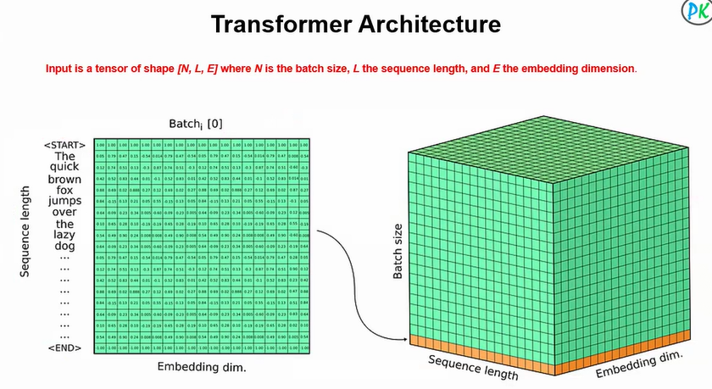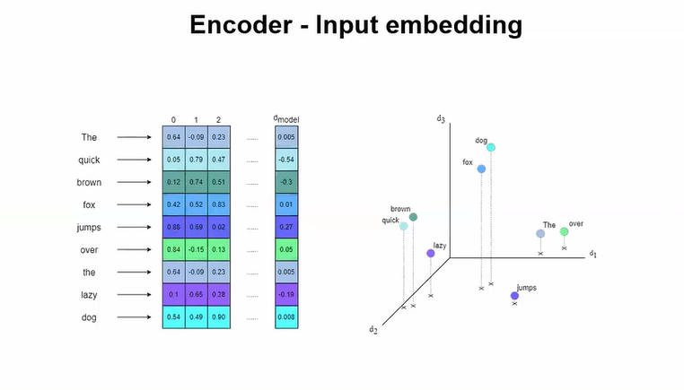

Positional Embedding in Transformer (Simple Words)
Transformers process all words in parallel.
So unlike RNNs, they don’t naturally know word order.
👉 That’s why we use Positional Embeddings.
Positional Embedding = Information about the position of a word in a sentence.

Why Is It Needed?
Sentence meaning changes with order:
- "Dog bites man"
- "Man bites dog"
Without position info, the model would treat them similarly.

What Positional Embedding Does
It adds a position vector to each word embedding.
Final Input to Transformer =
Word Embedding + Positional Embedding
So each word knows:
- What it means
- Where it appears
